Weekly Economic Update
June 26 – June 30, 2017
_________________________________

CHART OF THE WEEK

Few New Banks = Less Competition

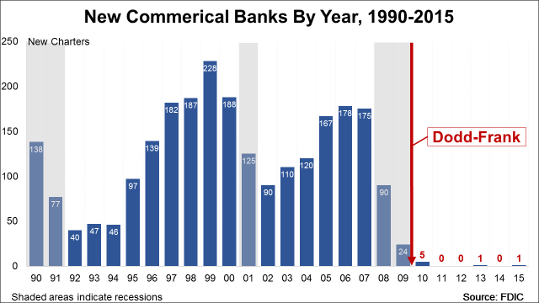

Following the recessions in 1990-1991 and 2001, market entry of new banks recovered. Even during the 2008-2009 recession there were 114 new banks. However, during the Obama recovery and following passage of Dodd-Frank financial regulation, the number of new banks opening their doors totaled only seven. The dearth of startups portends a loss of competition in the banking industry.

LAST WEEK
News & Commentary Weekly Highlights
Tax Foundation: Full Expensing Costs Less Than You’d Think
Wall Street Journal: U.S. Existing-Home Sales Rise in May Despite Tight Supply
Washington Post: FBI still looking for fugitive attorney who orchestrated $600 million government fraud

Top Economic Indicator Highlights
Existing Home Sales (May 2017)
Median sale price of existing homes

May: $252,800 (preliminary) April: $245,000 (revised) March: $236,600

Noteworthy: In May, the median home sales price was 5.8% higher than one year ago; since 2014, the average rate of increase has been 5%.

JEC Releases
It Doesn’t Have to be This Way: Obamacare’s Troubling Reality
Obamacare's Unstable Because of… Obamacare!

THIS WEEK
Upcoming Releases
CBO to release updated 10-year budget and economic projections (June 29, 2017, 2pm)

Upcoming Economic Data and Events
Monday
Revised Building Permits (8:00am)
Advance Durable Goods (8:30am)
Chicago Fed National Activity Index (8:30am)
Dallas Fed Manufacturing Survey (10:30am)

Tuesday
Consumer Confidence Index (10:00am)
Richmond Fed Survey (10:00am)
Dallas Fed Texas Retail Outlook Survey (10:30am)

Wednesday
Advance Economic Indicators (8:30am)
Pending Home Sales (10:00am)
Dallas Fed Energy Survey (10:30am)

Thursday
Gross Domestic Product (Final Estimate) (8:30am)

Friday
Personal Income/PCE Deflator (8:30am)
Chicago Purchasing Managers Index (9:45am)
Michigan Consumer Sentiment (10:00am)

